**Workflow Execution**

Steps to follow for implementing subscription workflow:

* Download WSO2 EI 6.5.0(BPS) & WSO2 APIM 3.1.0 from WSO2 official website
* By default BPS will be run on offset 2 with port number 9445
* Enable “TaskCoordinationEnabled” in humantask.xml and b4p-coordination-config.xml in WSO2 BPS configuration located at EI_HOME/wso2/business-process/conf



* Copy required epr files from API-M_HOME/business-process to EI_HOME/wso2/business-process/repository/conf/epr
* Update “SubscriptionCallbackService.epr” & “SubscriptionService.epr” (default+offset) port numbers where the services are running.

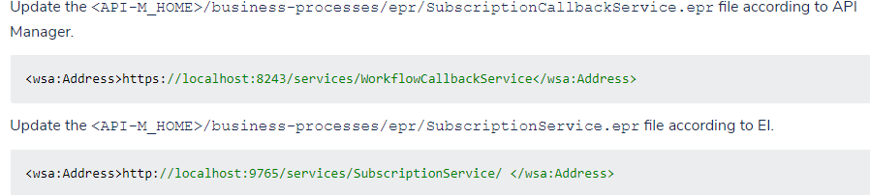

* Start BPS server
* <EI_HOME>/wso2/business-process/bin and run wso2server.bat
* Add BEPL <API-M_HOME>/business-processes/subscription-creation/BPEL/SubscriptionApprovalWorkFlowProcess_1.0.0.zip file to EI using management console

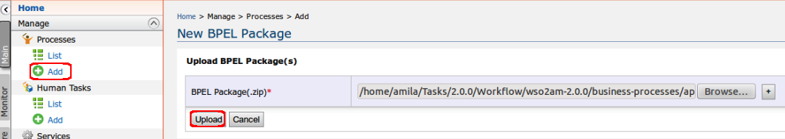

* Add HumanTask <API-M_HOME>/business-processes/subscription-creation/HumanTask/SubscriptionsApprovalTask-1.0.0.zip file to EI using management console in the same way as above
* Enable workflow by uncommenting simple workflow in “workflow-extensions.xml” from registry files of WSO2 APIM “/_system/governance/apimgt/applicationdata/workflow-extensions.xml”  
    
  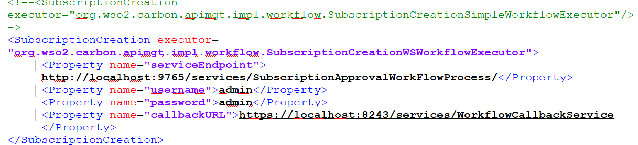
* Start APIM using <API-M_HOME>/bin/wso2server.bat
* Login into store and try to subscribe an API to an Application, the API will subscription state will be on hold

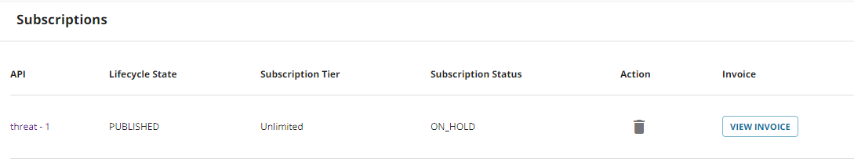

* Now login into admin portal, and you can find a task for approval and rejection.

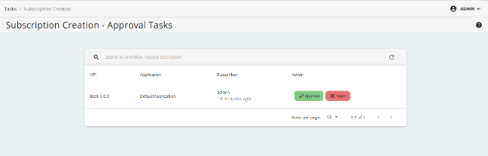

NOTE:

Please enable the connectivity between the below mentioned servers.

**Configuring WSO2 BPS**

* Subscription Callback service(SubscriptionCallbackService.epr) - Point to the gateway node of the APIM. (Default port - 8243) - Create access between BPS to Gateway node.
* Subscription service(SubscriptionService.epr) - Point to the BPS itself(localhost) - (Default port - 9765)

**Configuring the API Manager**

* Workflow Server URL(jaggeryapps/admin/site/conf/site.json) - Point to the BPS. (Default port - 9445) - Create access between Publisher node to BPS
* Workflow Extensions service endpoint(workflow-extensions.xml) - Point to the BPS. (Default port - 9765) - Create access between Devportal node to BPS. Since the registry database is shared between Devportal and Publisher, the workflow-extensions changes should be reflected in both nodes registry.
* Workflow callback service endpoint (WorkflowCallbackService.xml) - Point to the publisher node. (Default port - 9443) - Create access between Gateway node to the Publisher node.

NOTE:

* Add BPS certificate into “client-truststore.jks” of APIM in the location “APIM_HOME\repository\resources\security”
* Add APIM certificate into “client-truststore.jks” of BPS in the location “EI_HOME\wso2\business-process\repository\resources\security”